E-Mail Fishing

Youtube Video https://www.youtube.com/watch?v=u9dBGWVwMMA&t=805s
Youtube Video 1 https://www.youtube.com/watch?v=q3Y8O3I2u0A&t=163s
Git hub: https://github.com/whoamitang/Blackeye

11111111111
Git hub: https://github.com/whoamitang/Blackeye
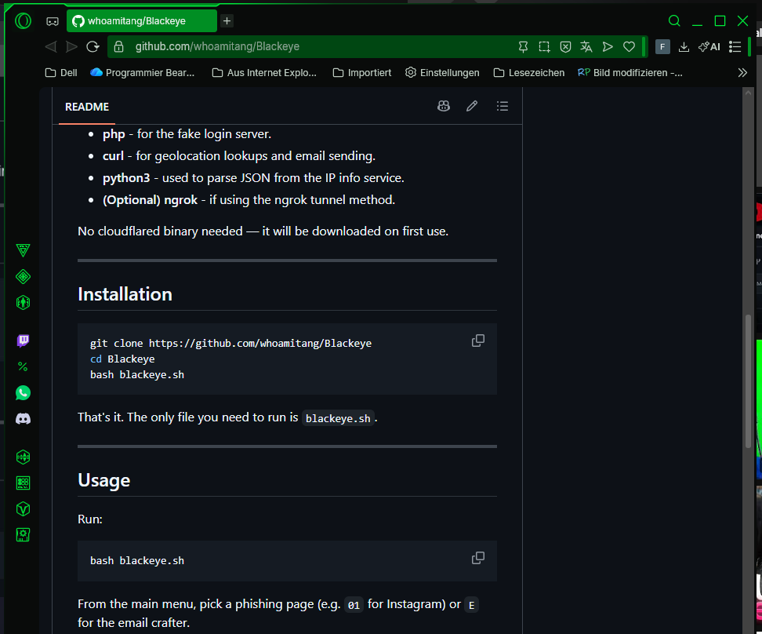

1111111111111111
git clone https://github.com/whoamitang/Blackeye

22222222222222222
cd Blackeye
222222222222
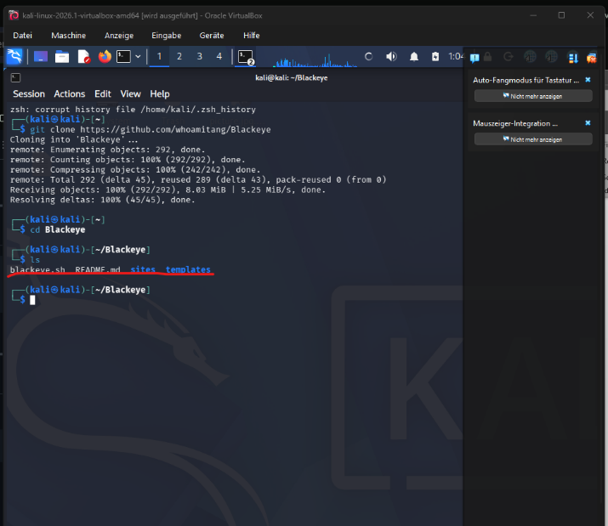
Ls

3333333333333333333333
bash blackeye.sh
44444444444444444444444
bash blackeye.sh
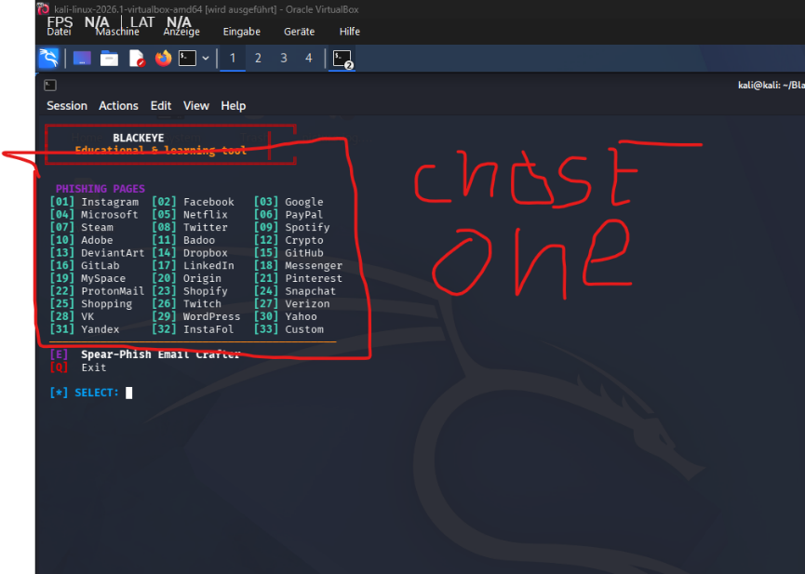
555555555555555555

77777777777777777777777777777777777777
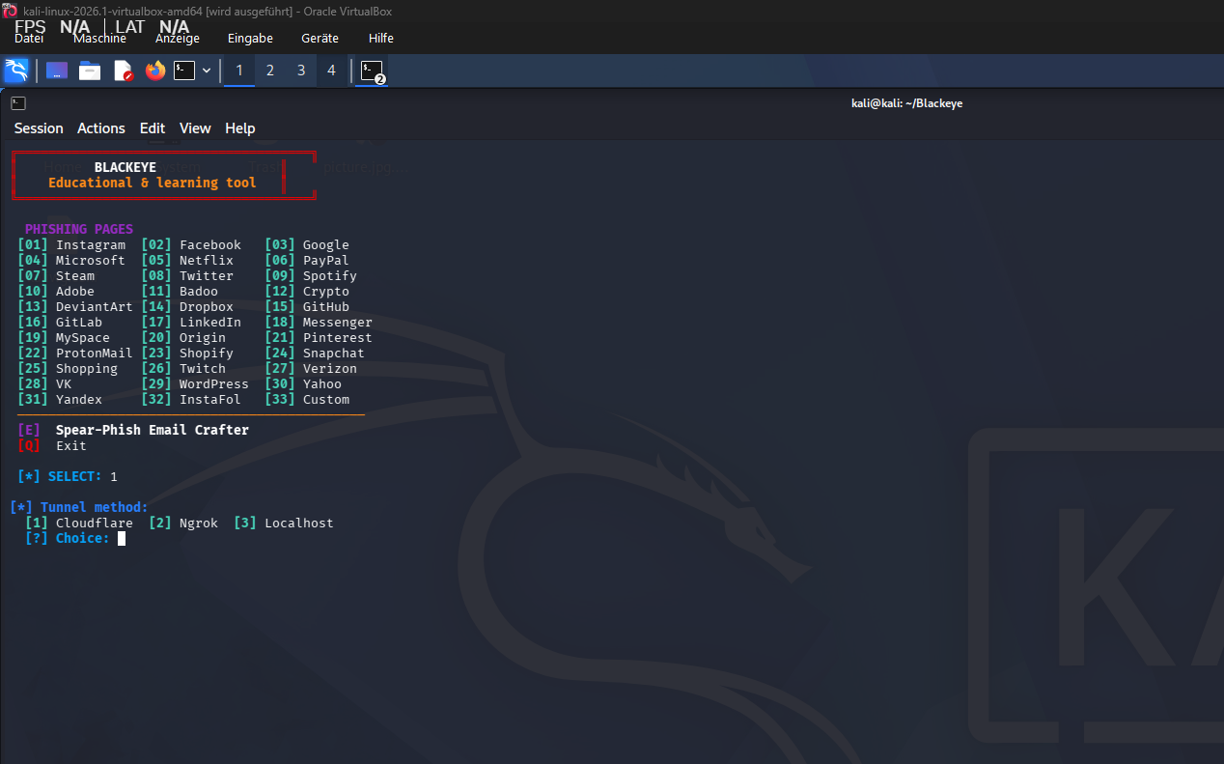
Press 1
22222222
Installing Cloudflare
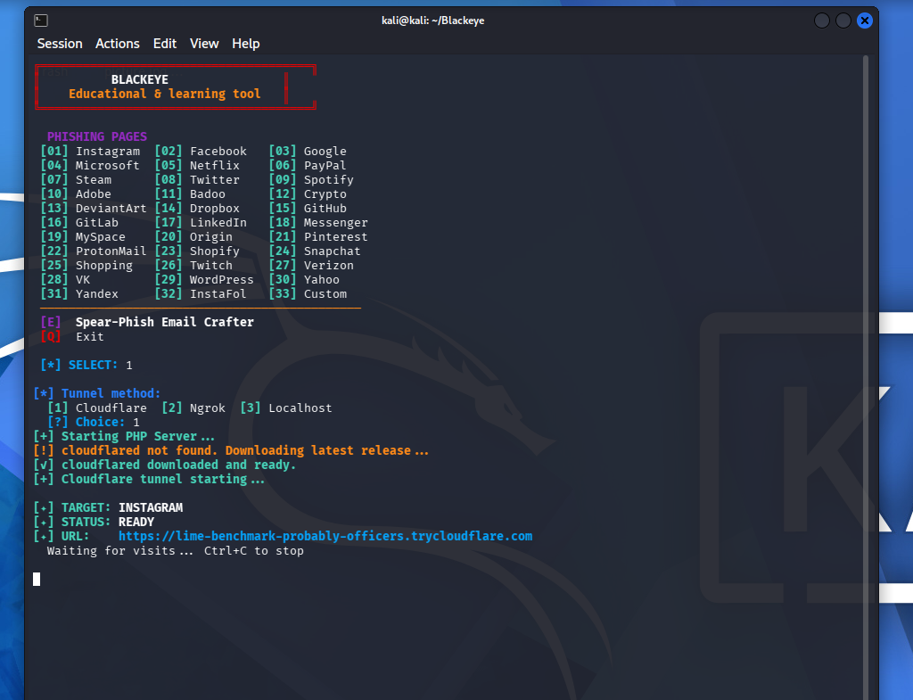

Oben Link
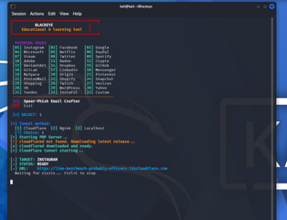
The link can be shared

If someone klick on the Internet the Password and name is showed there
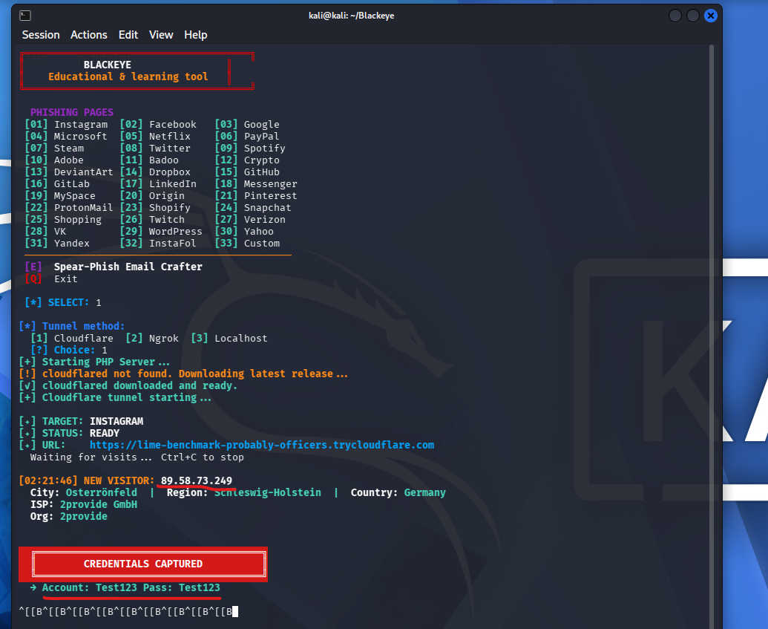

Press Strg + C

1111E-Mail Fishing with text11111

Youtube Video 1 https://www.youtube.com/watch?v=q3Y8O3I2u0A&t=163s
Git hub: https://github.com/whoamitang/Blackeye

11111111111
Git hub: https://github.com/whoamitang/Blackeye

111111111
cd Blackeye
2222222222
bash blackeye.sh
333333333333
Press E
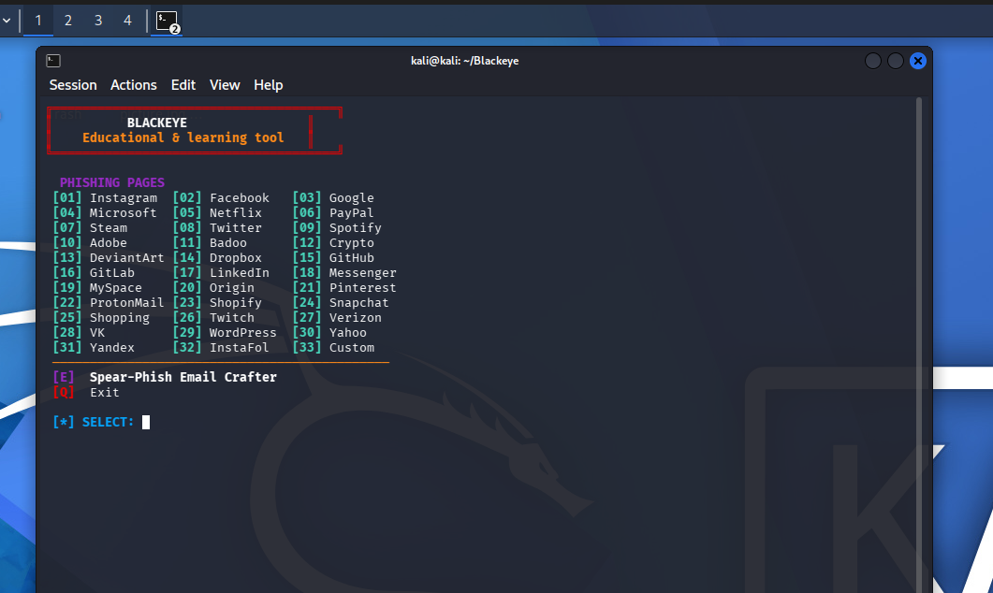
Press 1
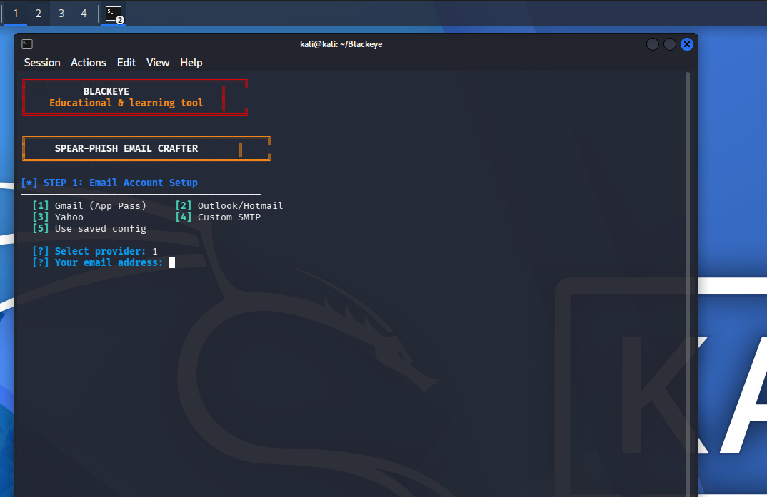
Type the face E-Mail
E-Mail: minecraft27182718@gmail.com
Pas 1234562718!
Name: Marcus Maier

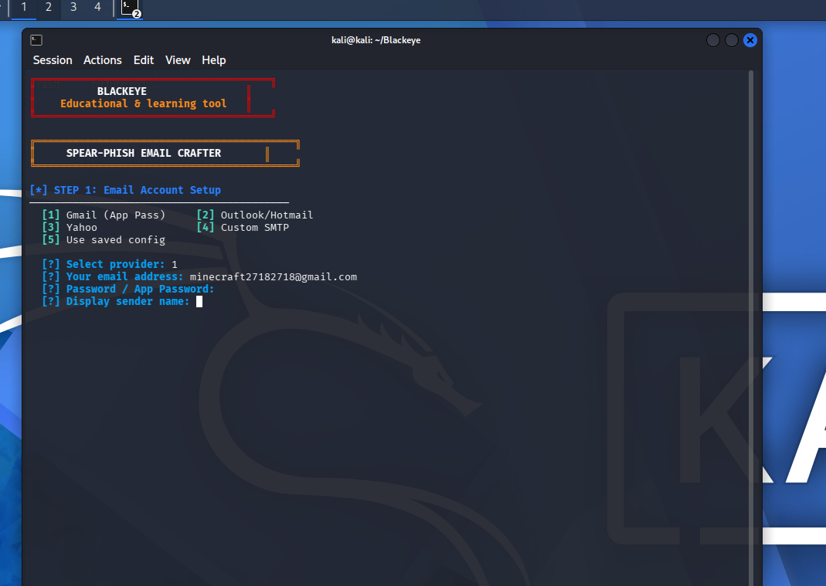
E-Mail: minecraft27182718@gmail.com
Pas 1234562718!
App Password
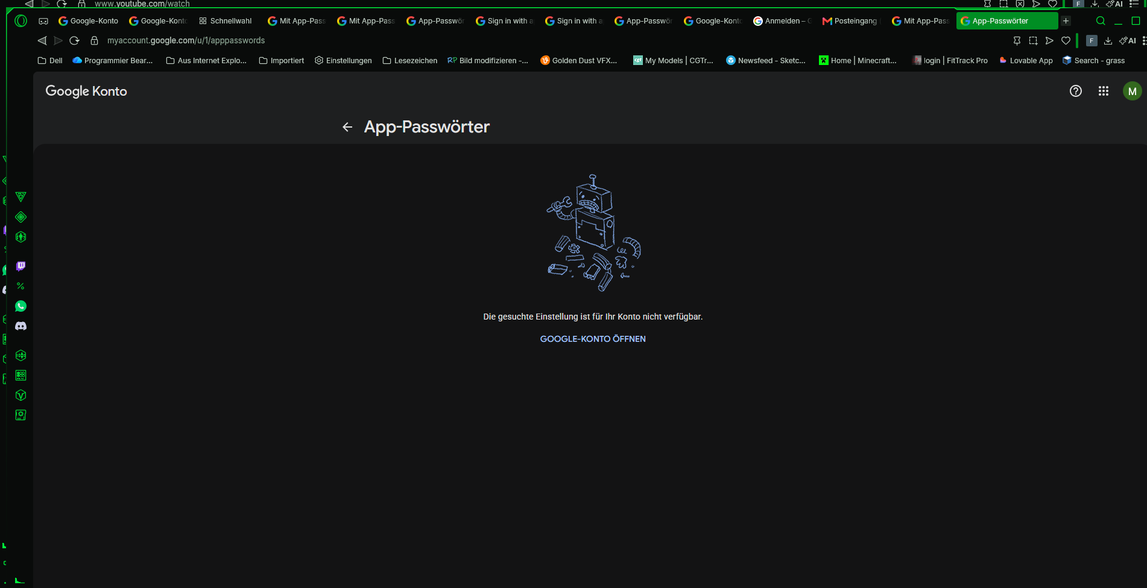
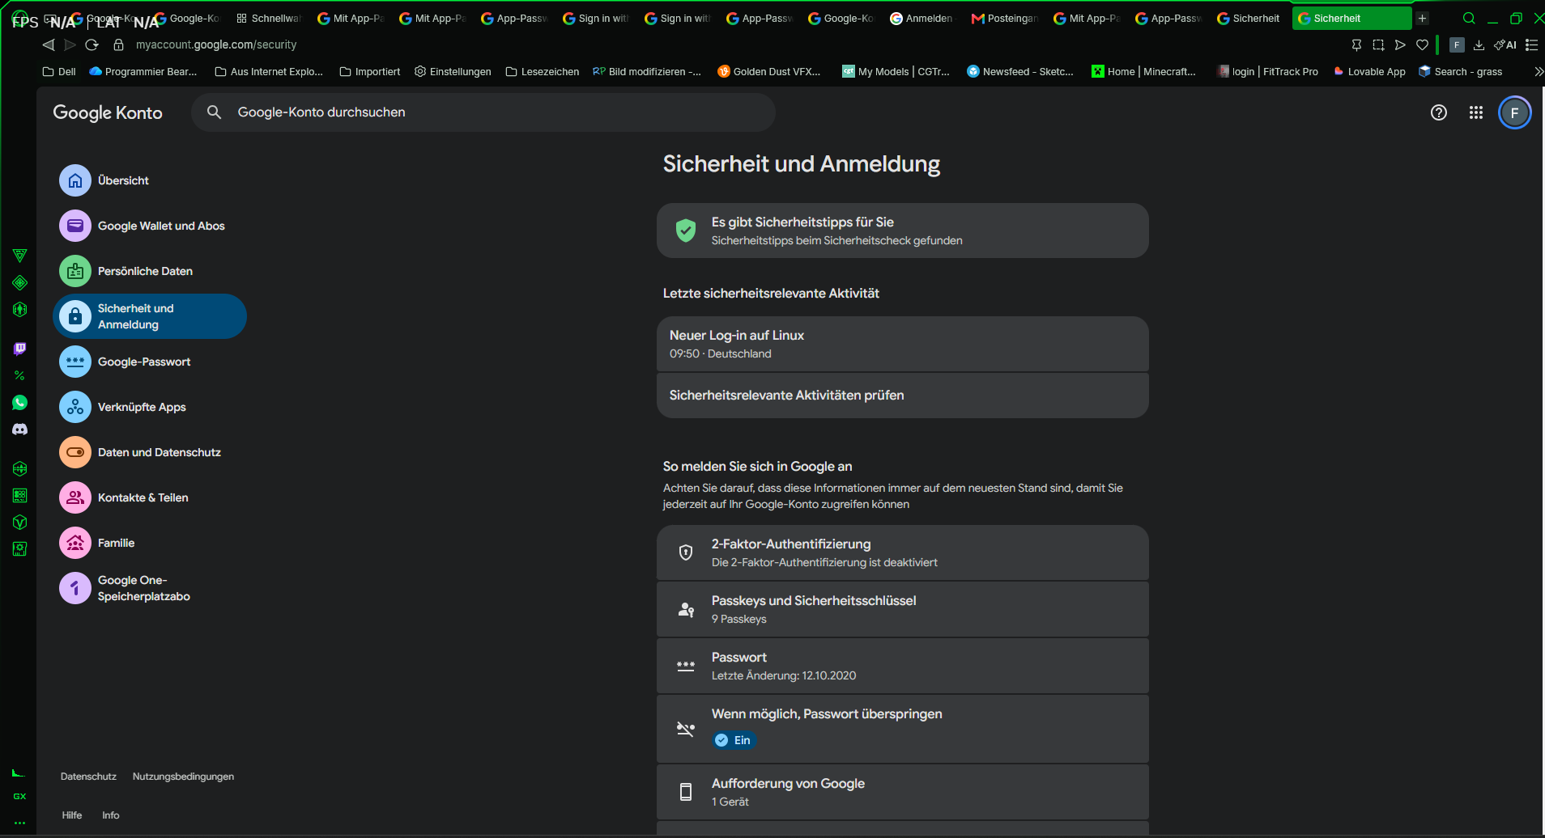
Ypu must make a 2 Faktor Authentication to make a google app password to make
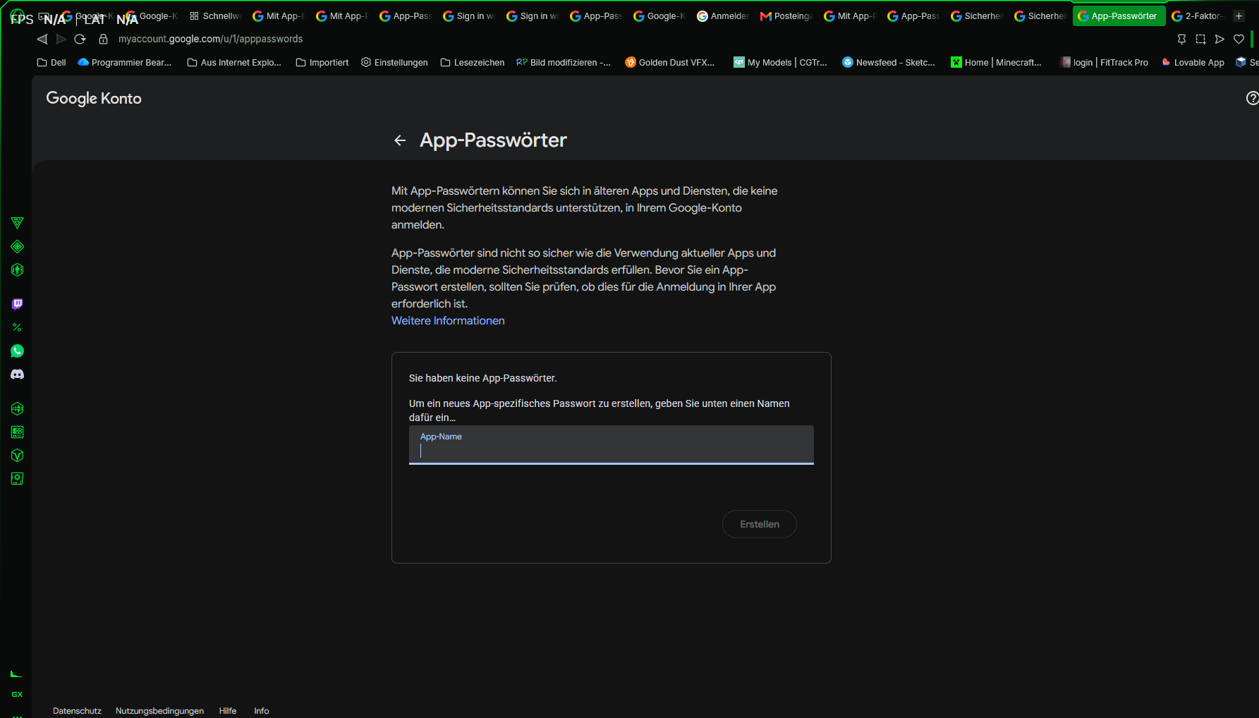
App Name Mail Test
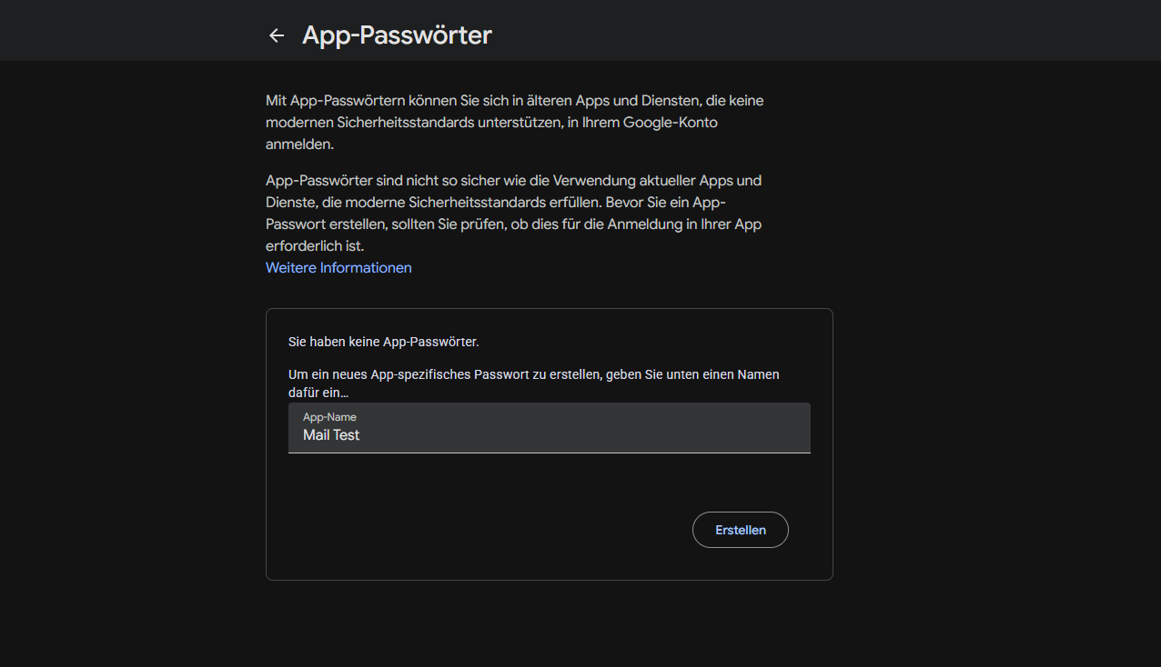
Googel App Passwort xggl mfya owzl taer

Name: Marcus Maier or Hacker
Press n
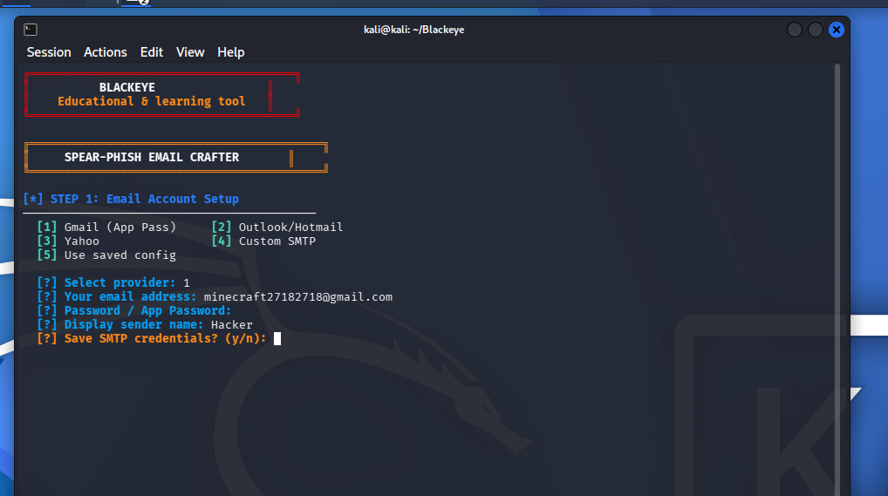

Chose 1
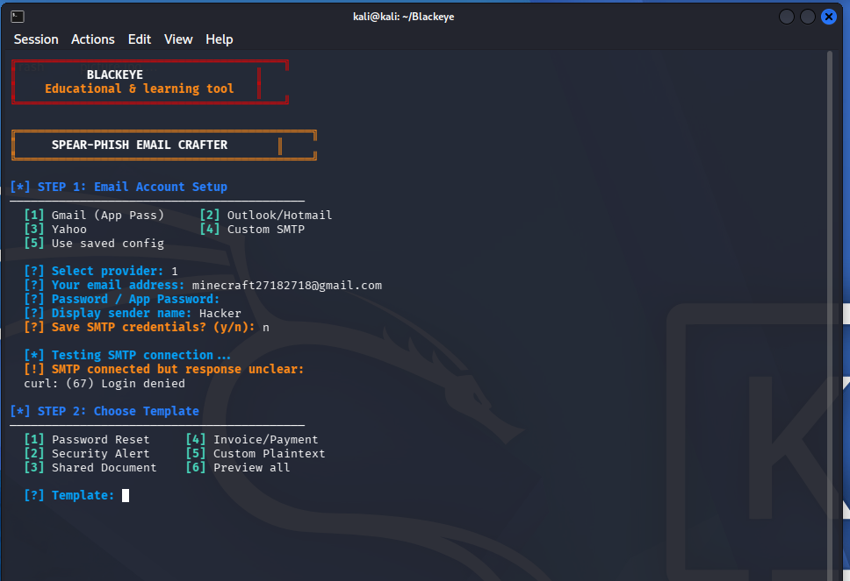
33333333333333
Fill in the Target E-Mail und den Target Namen und The Company
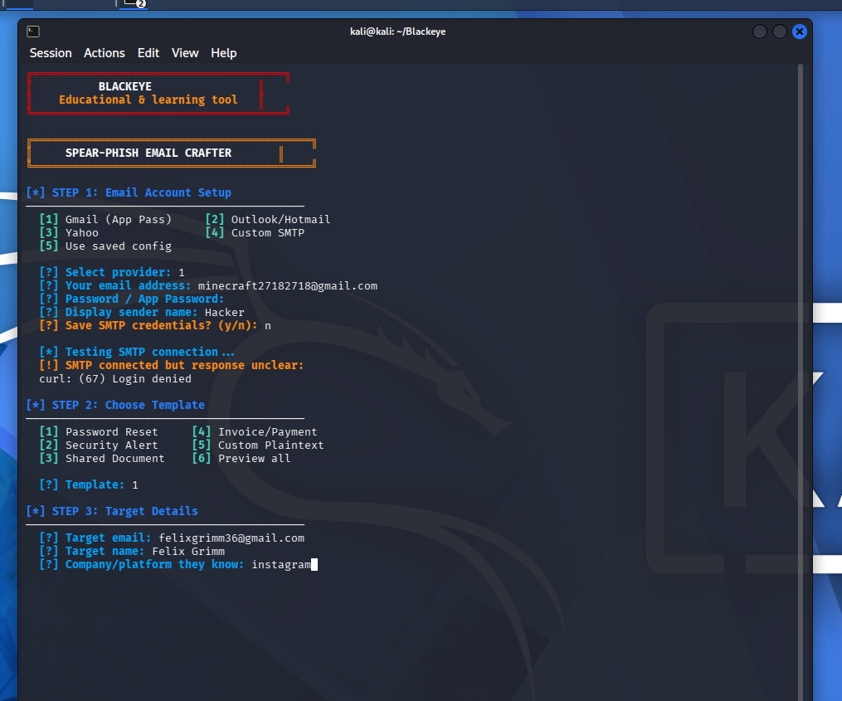
silvia.moser@moserhof.de

Open new tab
1111111111111
cd Blackeye
2222222222
bash blackeye.sh
33333333
Chose one attack
444444
Press 1
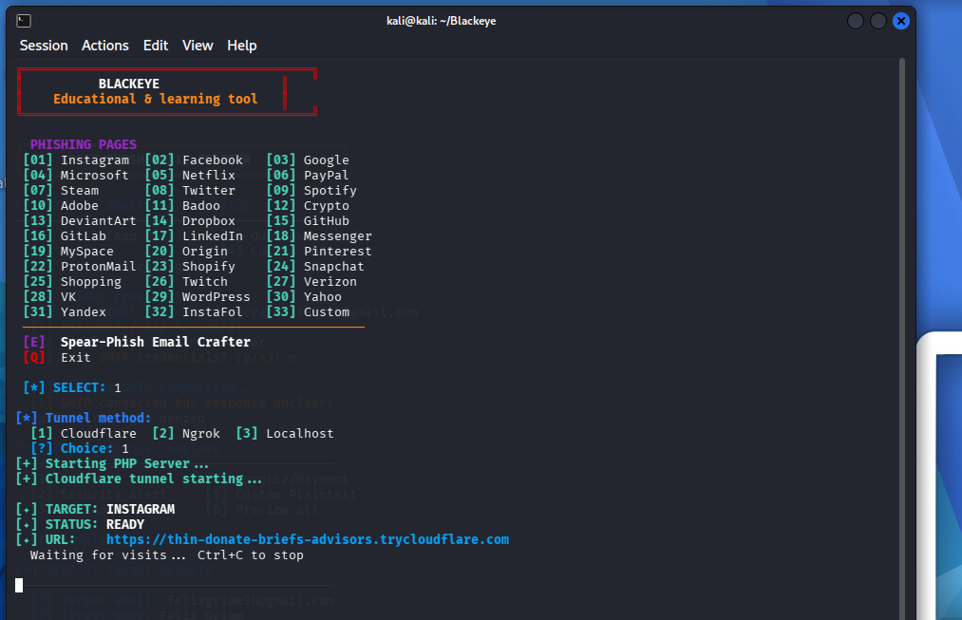
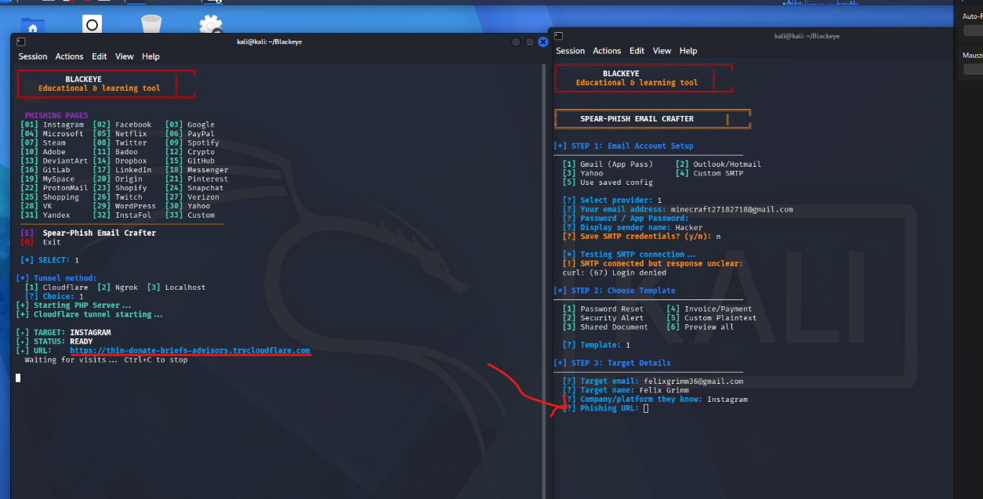
Copy the link in the other tab

Press 1
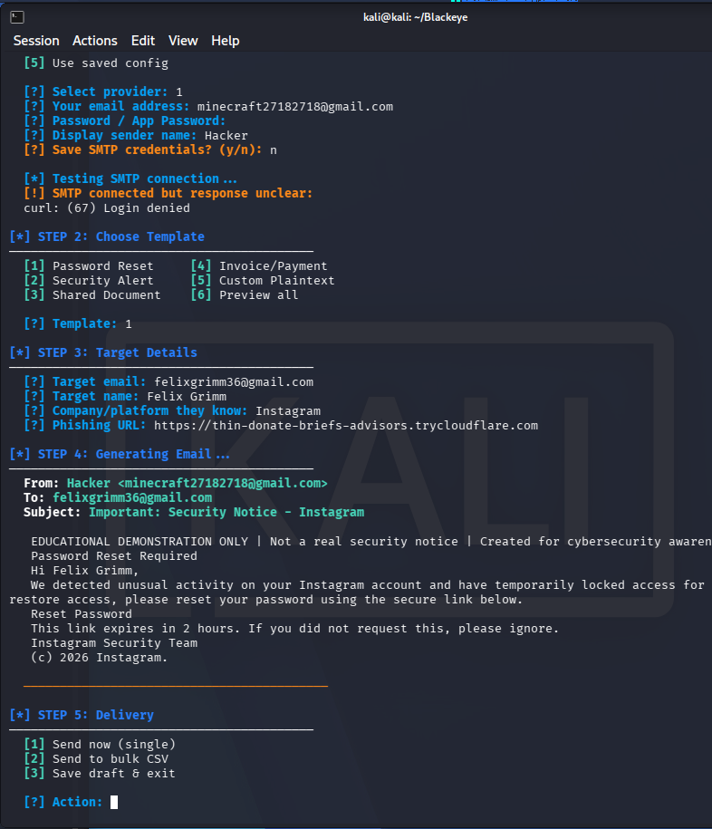

If its finish you can find it in Spam
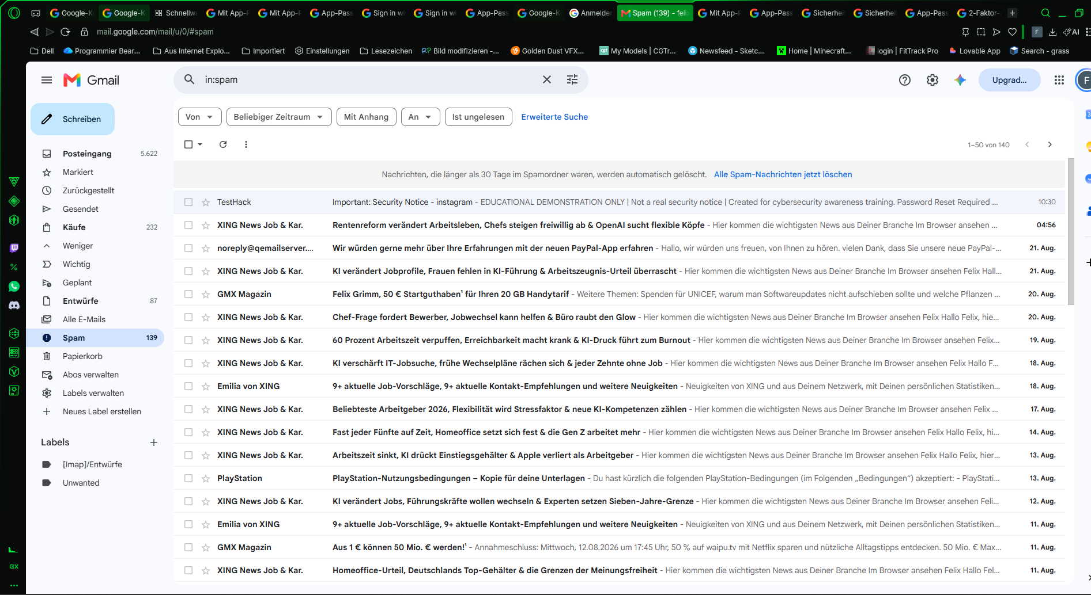

Make App Passwort
Google app password
Browser Link https://www.google.com/search?client=opera-gx&q=google+app+password&sourceid=opera&ie=UTF-8&oe=UTF-8

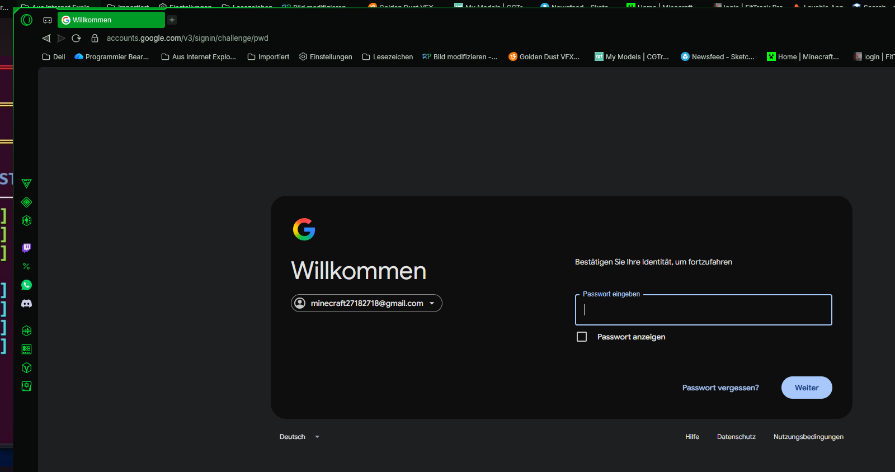
Passwort: 1234562718!

